Expanding Apprenticeships for People with Disabilities

Presenter:
David Hoff – david.hoff@umb.edu – 617-480-9230
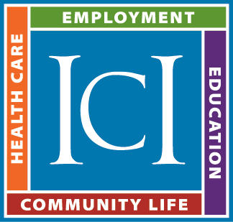
Institute for Community Inclusion
University of Massachusetts Boston
www.communityinclusion.org

What is apprenticeship?
- Industry-driven high quality career pathway
- Components:
  - Paid job combined with related instruction (work-based learning)
  - Increases in pay based on hours worked/competency achieved
  - Mentoring
  - Industry credential
- Apprenticeships are available in a diversity of fields
- Remember: apprenticeship is paid employment
- Know the difference: apprenticeship, internships, etc.

Why apprenticeship?
- For individuals: highly structured, systematic earn and learn approach resulting in skill development, stable employment, and movement along a career pathway.
- For employers: opportunity to hire and train individuals according to industry standards, and meet workforce needs.

Apprenticeship Models
- Pre-Apprenticeship – preparatory for apprenticeship
- Industry Apprenticeship – apprenticeship created by industry using apprenticeship model
- Registered Apprenticeship – apprenticeship approved by US Department of Labor or state apprenticeship office, using federal standards

Apprenticeship Roles
- Sponsor: organizational body
- Employer: provider of on-the-job training (Registered apprenticeships: 2000 hours minimum)
- Related Instruction: Registered apprenticeships: 144 hours
- Support Services

Partnership is key:
- Federal/state apprenticeship offices
- VR
- Workforce development
- Community colleges
- Local Education (K-12)
- Employers
- Labor organizations
- Community organizations
- Economic development

Challenges for People with Disabilities
- High level of structure and standards not always flexible
- Accommodation and support needs
- Disclosure issues
- Traditional culture of apprenticeships

Potential Roles of VR and Service Providers
- Supports
- Sponsor
- Funder of related instruction
- Convener
- Employer
- Others

Resources:
- ICI – Explore VR: Rural Youth Apprenticeship Project - https://www.explorevr.org/content/research-projects-explorevr
- Institute for Community Inclusion – ExploreVR Apprenticeship Toolkit - https://www.explorevr.org/toolkits/apprenticeships-toolkit
- Jobs for the Future National Innovation Hub for Diversity Equity Inclusion and Accessibility - https://www.jff.org/what-we-do/impact-stories/center-for-apprenticeship-and-work-based-learning/diversity-equity-and-inclusion-apprenticeship-wbl/
- US Department of Labor Apprenticeship Resources - https://www.apprenticeship.gov
- StartTodaySD Apprenticeship Information - https://www.starttodaysd.com
- South Dakota Department of Labor & Regulation Apprenticeship Information - https://dlr.sd.gov/workforce_services/individuals/training_opportunities/apprenticeship.aspx

